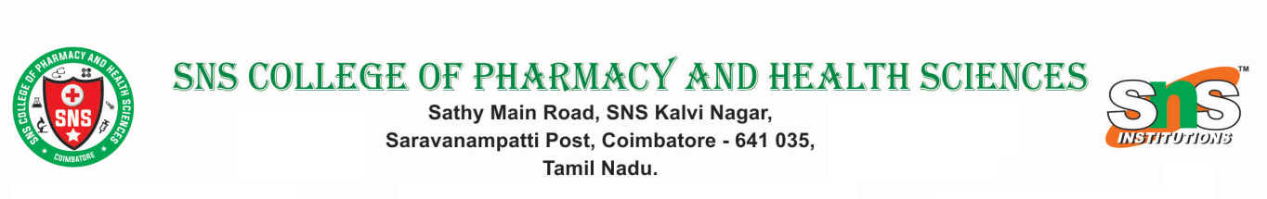

ANTI-RAGGING SQUAD

S.NO | Name of the Member | Designation | Contact Number
1 | Dr. S. Satheh Kumar | Principal | 9713597175
2 | Mr. Sivasubramanian P | Teacher Representative | 9487225079
3. | Mr.Nallakumar Ponusamy | Teacher Representative | 9642008626
4 | Mrs. Betty Rani | Non-Teaching | 8870810867
5. | Mr. Saravanan D | Rector Boys-Hostel | 8122426035
6. | Mrs. Vanaja | Rector Girls-Hostel | 9894922033

